
Computer Networks Lab_241L
UW-24-CS-BS-101
Registration NO:
Muhammad Talha_CS.3ndB
Lab Task # 08
UNIVERSITY OF WAH(UOW)

DEPARTMENT OF COMPUTER
SCIENCE

COURSE:

SUBMITTED TO:

Mr. Hassan Shafaqat
SUBMITTED BY:

Dynamic Routing
Adding PC
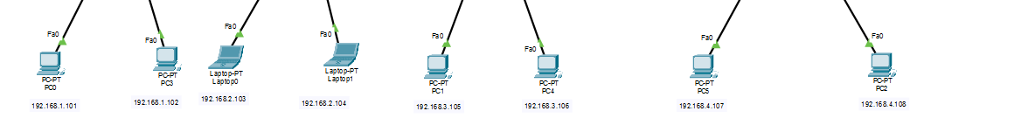
Adding Switches and Routers
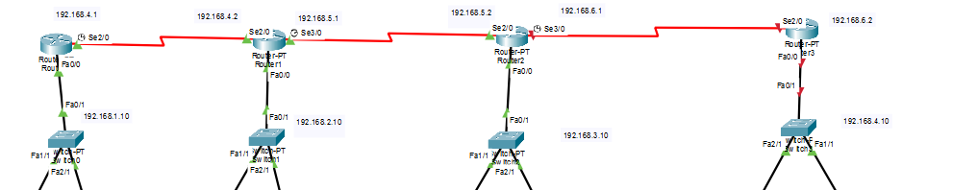
Adding IP address
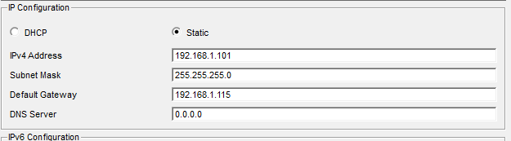
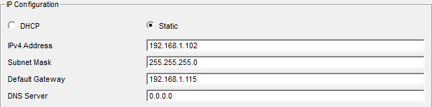
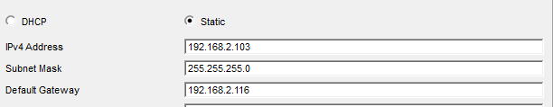
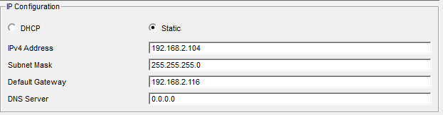

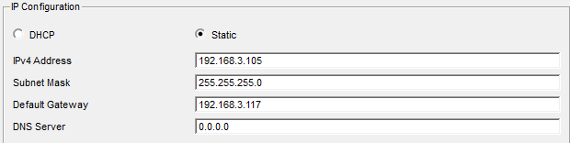
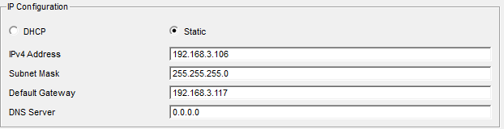
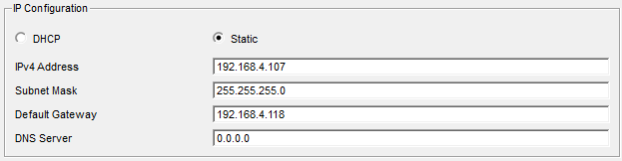
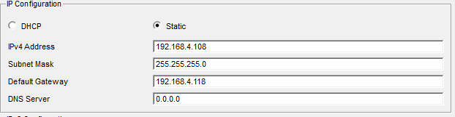
Now Router IP Assigning
Router 1:
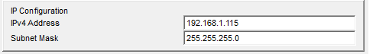
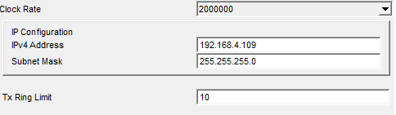

Router 2:
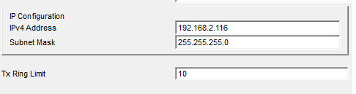
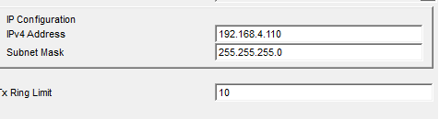
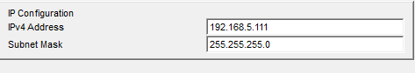
Router 3:
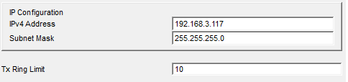
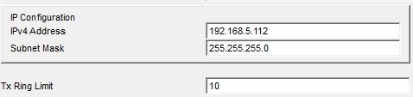
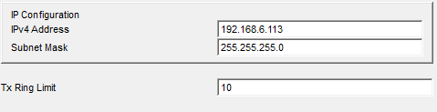
Router 4:
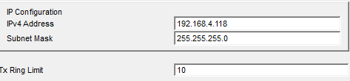
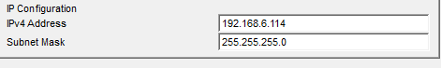

Assigning RIP to each Router:
Router 1:
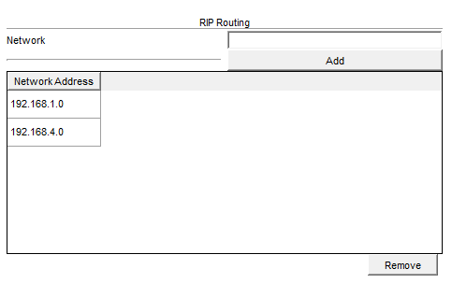
Router 2:
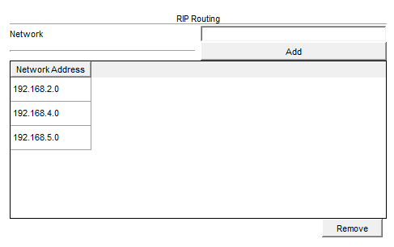
Router 3:
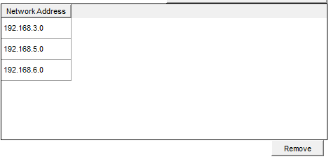

Router 4:
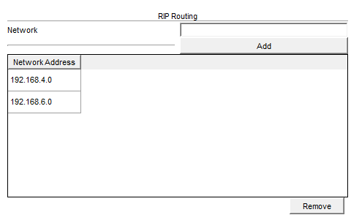
Sending Router to Router
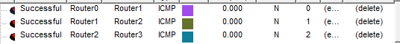
Sending Message to Each PC/Laptop
From PC0 to All:
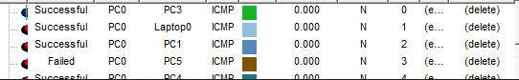
From PC1 to All:
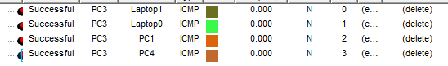
From PC2 to All:
From PC3 to All:
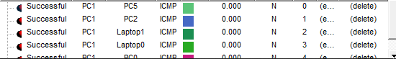
From PC6 to All:
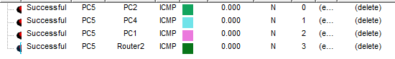

From PC7 to All:
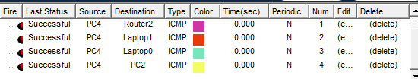
From PC8 to All:


